**Creating Docker Image**

1. **Launch RHEL 7.4 instance in AWS**



1. **connect the instance using putty**

Login as :ec2-user

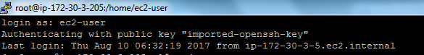

1. **Install Docker** 
   1. pre-requisite for container-selinux-2.9-4.el7.noarch.rpm

|  |
| --- |
| **$ sudo yum install policycoreutils-python**  **$ wget** [**http://mirror.centos.org/centos/7/extras/x86_64/Packages/container-selinux-**](http://mirror.centos.org/centos/7/extras/x86_64/Packages/container-selinux-) **2.21-1.el7.noarch.rpm**  **$sudo rpm -i container-selinux-2.21-1.el7.noarch.rpm** |

* 1. Set up the Docker CE repository on RHEL:

|  |
| --- |
| **$ sudo yum install -y yum-utils**  **$ sudo yum install -y device-mapper-persistent-data lvm2**  **$ sudo yum-config-manager --enable rhel-7-server-extras-rpms**  **$ sudo yum-config-manager --add-repo https://download.docker.com/linux/centos/docker-ce.repo**  **$ sudo yum makecache fast** |

* 1. Install the latest version of Docker CE on RHEL:

|  |
| --- |
| **sudo yum -y install docker-ce** |

* 1. Start Docker:

|  |
| --- |
| **sudo systemctl start docker** |

1. **Copy source code to the instance launched (rhel machine) using file transfer(WinScp)**

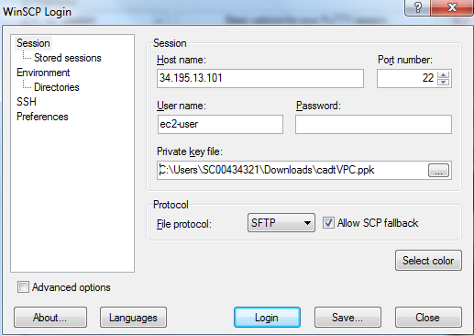

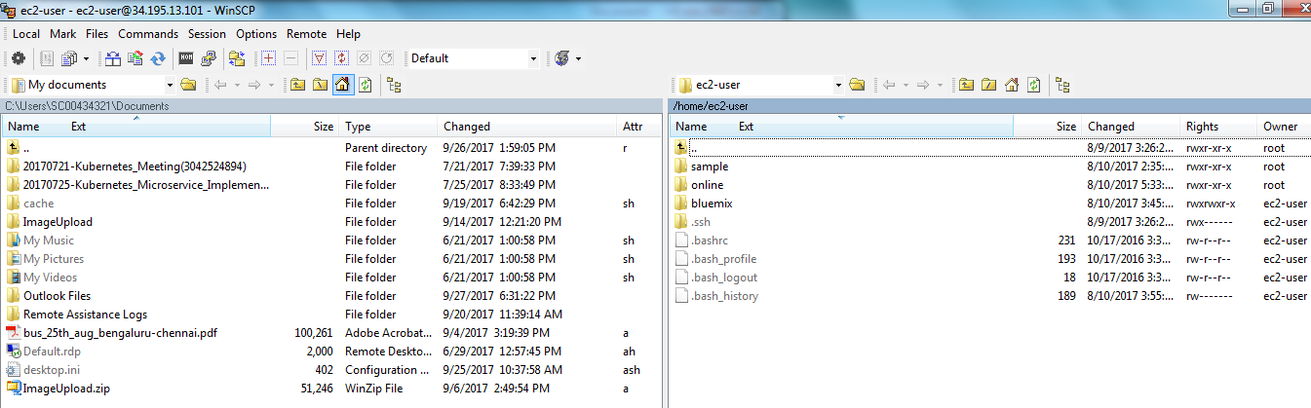

Copy the source code from local to the instance launched

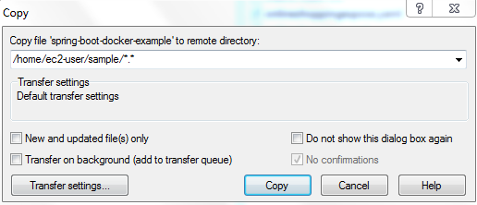

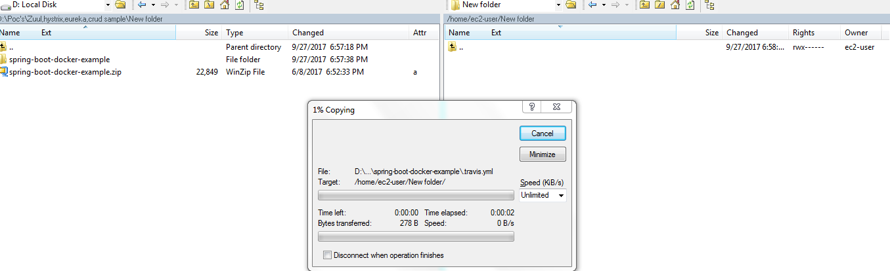

1. **Creating Docker Images**
   1. Navigate to the source directory in Rhel machine



* 1. Build the maven code (make sure that java and maven already installed)



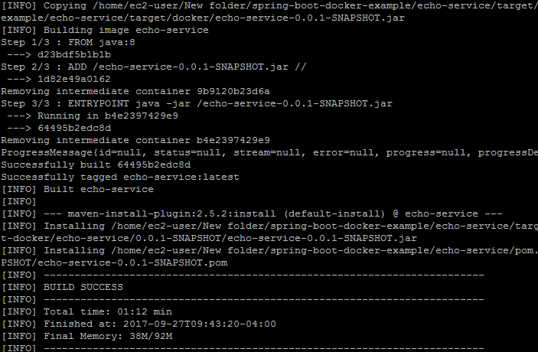

Image build successfully!!!



1. **Push Docker Images to docker hub**
   1. Login to docker hub:

|  |
| --- |
| **$ docker login** |



* 1. Tag the image:

|  |
| --- |
| **$ docker tag echo-service techmroot/echo-service** |



* 1. Push the Image:

|  |
| --- |
| **$ docker push techmroot/echo-service** |

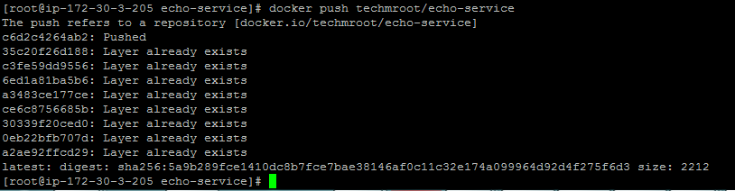

**Image pushed to the docker hub successfully!!!**